TIME SERIES DATA ANALYSIS AND FORECAST METHODS

Lecture 5
Typical time series autoregressive models

Yekaterinburg
2017
Contents

Lecture purpose 3

Lecture map 3

Part 1. Autoregressive models 4

Part 2. Moving-average models and complex ARMA models 6

Part 3. Stationarity criterion for ARMA models 8

Part 4. Estimations of AR models 10
4.1. Autoregressive model of first order 12
4.2. Autoregressive model of second order 14
4.3. Autoregressive model of higher order 14

Part 5. Estimation of moving-average models 16
5.1. Moving-average model of first order 17
5.2. Moving average model of second order 17

Part 6. Complex ARMA and ARIMA models 18
6.1. Autoregressive – moving-average (ARMA) model 18
6.2. Autoregressive – integrated moving-average (ARIMA) model 20

Part 7. General technique for initial estimation of ARMA and ARIMA coefficients 21
References 23

Lecture purpose
The purpose of this lecture is to form knowledge, skills and abilities of application of a technique for creation of autoregressive models for time series on the basis of the analysis and assessment of their characteristics, and also studying of key features and standard schemes of implementation of recurrent algorithms for calculation of models.

Lecture map

- Basic autoregressive model (AR) models
- Basic moving-average (MA) models
- Examples of AR models
- Examples of MA models
- Complex ARMA models
- Non-stationary ARIMA models
- Difference scheme between models of ARIMA and ARMA
- Initial estimation of ARIMA coefficients

Part 1. Autoregressive models
The fact that the time series is an arranged sequence of observations of some selected stochastic process can be in itself an indicator of properties of model which is its cornerstone. It is often convenient to describe similar data in the form of mechanisms by influence of the previous observations on results of the subsequent. Such models just called autoregressive such as models in which the current value of process is expressed as final set of the previous values of process and some residual data. Especially such models, obviously, will be very convenient for forecasting where the purpose is to calculate future observations from previous known data.
Not to get confused in this difficult area of tasks, we will start anew from key concepts of the theory of similar models. As the majority of expressions in a complete form will turn out rather long (we should consider all possible dependences on the previous observations), we will enter several useful operators:

Back shift operator B
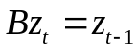, (5.1)
Forward shift operator 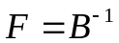
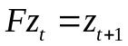, (5.2)
Difference back shift operator 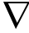
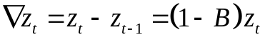, (5.3)
Difference forward shift operator 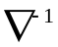
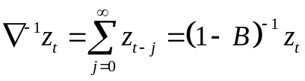 . (5.4)

Taking into account these designations, and also if assume 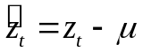, where 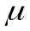 – level or tendency of process, autoregressive model of an order p = AR(p) defined as:
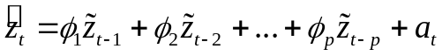 (5.5)

It turns out those values of data z «regress» on previous values. Equation (5.5) looks rather long, therefore, with autoregressive operator
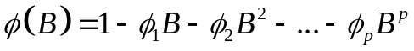 , (5.6)
the autoregressive model is compressed into expression
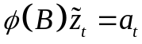 (5.7)
Formulas (5.5) and (5.7) are completely equivalent. It is easy to notice that there are a model of an order p which contains p+2 of unknown of parameter, and stay them will just be a problem of creation of autoregressive model. In all these expressions 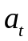 is some random impulse or a data while the important principle of separation of TS into the determined and accidental components still remains also for autoregressive models. This universal representation allows us to use the same statistical criterions that we already applied to the analysis of TS earlier, and also to apply if stationarity of TS, autocorrelation and spectral methods which will be useful to us is set.

Part 2. Moving-average models and complex ARMA models
The autoregressive model (5.5) expresses a time series point as the final weighed sum of the previous observations plus an accidental impulse. But if to remember a form of the general additive model, then often in TS future values of a row can depend on the previous samples of stochastic component. Then similar models in which 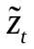 linearly depends on a finite number of the previous a
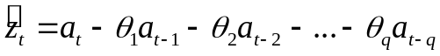 (5.8)
are called models of the moving-average of an order q = MA(q). With the definition similar to (5.6) by moving-average operator
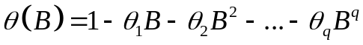 (5.9)
the model MA(q) in short form will be presented in the form
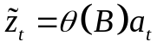 (5.10)
For achievement of bigger flexibility in adjustment of models, it is better to combine these two types of models in something the general, having called them the mixed autoregressive – moving-average model order (p,q) ARMA (p,q):
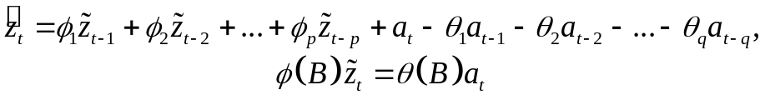 (5.11)
In practice, despite a terrible expression (5.11), sufficient is a reduction of the ARMA model to an order (p, q) of 2 and 3, and sometimes even less.
It should be noted that the general model (5.11) is stationary, that is before using it, we should check TS for stationarity, and only then to be engaged in adjustment of model. What to do, if tests showed that TS is non-stationary? In this case we refuse use of autoregressive models, or consider narrower class of non-stationary TS for which an expectation value and variance change, but time series is somewhat homogeneous. In this case, it turns out though TS will be non-stationary, but some difference of it will be stationary that was already discussed in the previous lectures by consideration of a concept of unit roots. Such homogeneous non-stationary process ARIMA is written in shape:
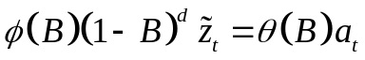 (5.12)
or in the form
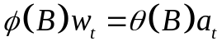 (5.13)
where 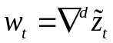 – non-stationary process.
The models described by expressions (5.12) and (5.13), called the models of autoregressive – integrated moving-average оf order (p,d,q) = ARIMA (p,d,q). With d=0 model is reduced to the stationary case. Where from came the “integrated” part? It appears from the definition of 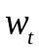: by inversing the difference shift operator 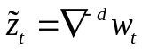, we can estimate as
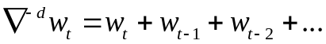 , (5.14)
therefore, we sum up components, that is, "we integrate" them.

Part 3. Stationarity criterion for ARMA models
The concept of stationarity of TS was already discussed many times, for there are strict theoretical definitions and some statistical tests. In relation to the ARMA models this concept appears to be used much more conveniently in the form of search of roots of a characteristic polynomial, than to use bulky statistical tests. The concept of single roots was already mentioned in lectures earlier, but now when we know how the ARMA model generally looks, it is now possible to understand from where they in general undertook and as through them it is possible to define stationarity or non-stationarity of TS.
In a broad sense the fact that dispersion of process will be of course is a consequence from stationarity determination and it is permanent. It means for the ARMA models that generating function of weights 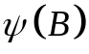:
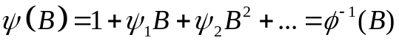 (5.15)
is some polynomial which has to converge at 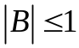, thus polynomial roots must be inside unit circle.
Equivalence between stationarity of a time series and convergence of a polynomial is not obvious, but is proved in a strict theoretical form where unambiguous compliance between dispersion of process and is established. Here this proof is not considered, in, force of its big size of the description.
Function of weights is inconvenient for us as in the ARMA models we operate with 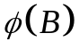. Therefore finally to pass to a concept of unit roots, we will give a definition to a stationarity for AR models on the basis of .
The equation 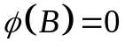 is called a characteristic polynomial process, and its roots serve as an appraisal remedy of stationarity for process, as depending on their ratio which decides on unit expression process. Process AR as described in form of is stationary, if the roots of the equation lie outside о the unit circle.
Similarly stationarity determination AR of processes extends through additional functions at first on processes of MA, and then and on the mixed ARMA models.
Thus, check on stationarity of TS, described by the ARMA models, it is possible to reduce to search of unit roots characteristic polynomial , or at once to use the statistical KPSS-test or the ADF-test which rely just on this definition, but at the same time operate with more exact concepts of statistical hypotheses and significance levels.

Part 4. Estimations of AR models
Let for designated TS 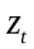 we define, that it is stationary and roots of a characteristic polynomial are outside the unit circle. For AR model order оf p we need to find p+2 parameters unambiguously to compare samples of data with its AR(p) model.
For this purpose we multiply the equation (5.5) by 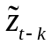 and receive:
. (5.16)
Because the TS is stationary, we can estimate the expectation mean value 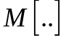 for (5.16), taking into account that the determined and stochastic components are separable 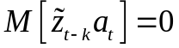 for 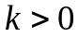:
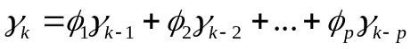 (5.17)
Dividing this difference equation by 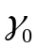, we will receive, by definition, the difference equation consisting of autocorrelation functions:
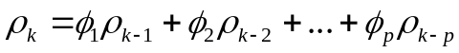 (5.18)
In abbreviated form (5.18) is represented as 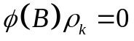. Now we have k linear equations with k unknown – we can evaluate autocorrelations as it was shown in the previous lectures. The system of these equations in a canonical form is called Yule-Walker's equations:

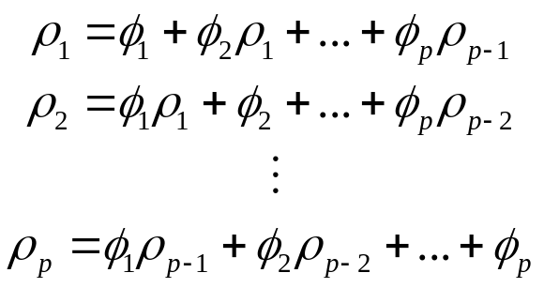 (5.19)

The equation (5.19) in matrix form is:
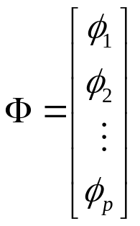, 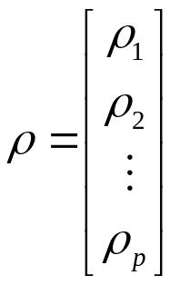, 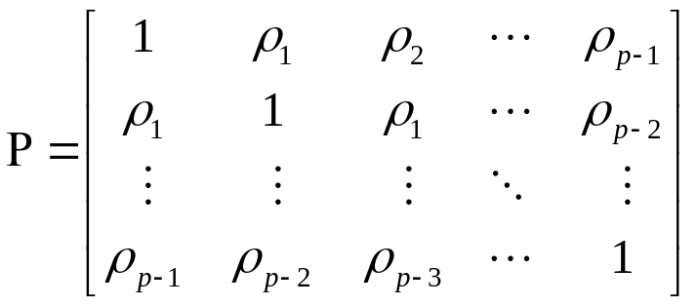
therefore:
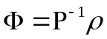 (5.20)
If needed it is possible to show that this method is equivalent to a simple least-squared method of determination for linear regression coefficients from the known points of data.
Dispersion or variance оf those AR processes, from equation (5.17), will be calculated with this formula:
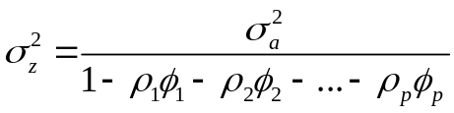 , (5.21)
and autocorrelation function of AR(p) therefore will look as set of the fading exponents and sinusoids.
Expressions (5.19), (5.21) look rather bulky. But in practice often it is enough to consider the ARMA models 1 and 2 of orders, and models of higher orders can be received recurrently on their basis.

4.1. Autoregressive model of first order
For such process everything is rather easy and simple, with p=1. Let the time series 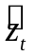 оf length N have a model of AR(1):
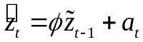, (5.22)
where – white noise with charactseristics 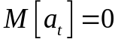 и 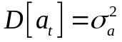.
Then from formulas above:
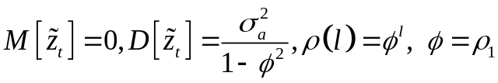 (5.23)
Using the estimates of autocorrelation function (2.17) given in the second lecture it will be possible to find , then to select a stochastic component of data: 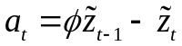.
On figure 5.1 there are two types о AR(1) time series 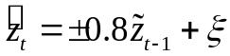, their autocorrelation functions are given in the figure 5.2.

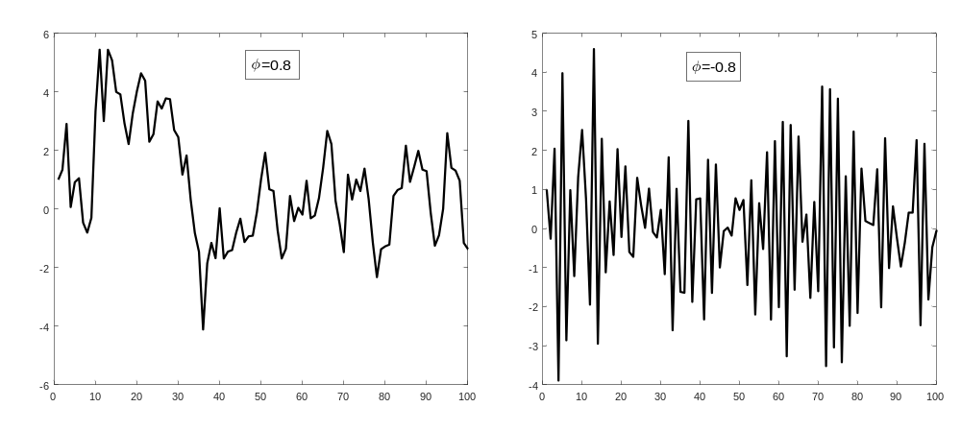
Figure 5.1 – AR time series о first order with positive link (left)
and negative link (right)

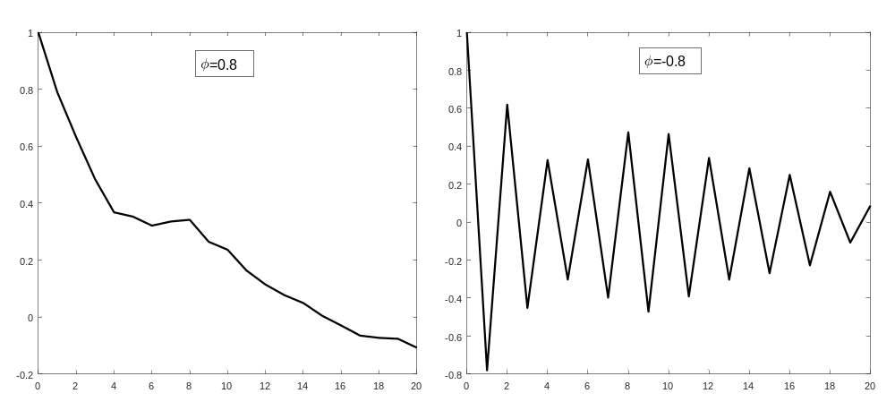
Figure 5.2 – Autocorrelation functions of data from fig. 5.1.

Notice, how clearly it is visible, that 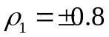, that is autocorrelation function is quite possible for use un estimation of AR models parameters.

4.2. Autoregressive model of second order
Let the time series о length N have a model AR(2):
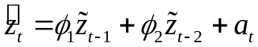, (5.24)
where – white noise with characteristics и .
Analogically, we receive:
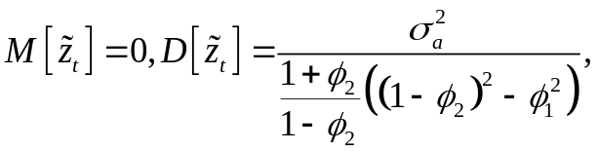 (5.25)
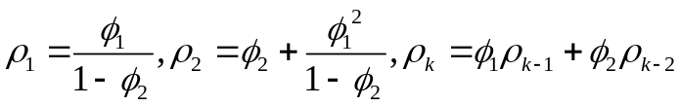 (5.26)
from where we receive required estimates of the AR(2) parameters:
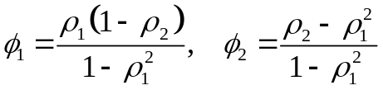 (5.27)

4.3. Autoregressive model of higher order
Even for an AR model оf second order, it is possible to notice from (5.26) that instead of a solution of the Yule-Walker equations (5.19) assessment of parameters for AR(p+1) model can be received if estimates of AR(p) adjusted for the same time series are known.
Let's give at first an example of such recurrence relations for AR(3), and then we will show a difficult general formula. Sample partial autocorrelations can be received from formula:
(5.28)
where 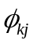 – j-coefficient оf partial AR(k).

For k=2 based on (5.28) we receive:
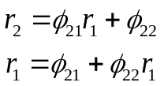 (5.29)
For k=3 based on (5.28) we receive:
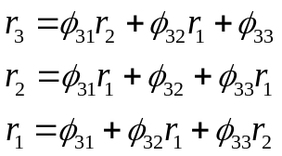 (5.30)
And from here we receive:
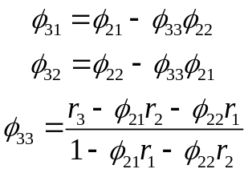 (5.31)

From partial AR models о lower order we can estimate the coefficients оf AR оf higher order. In general view formulae are considered through the expressions (5.32) and (5.33) and called by Darbin equations.

(5.32)
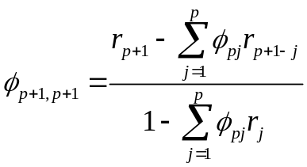 (5.33)

Part 5. Estimation of moving-average models
Let for known time series we defined, that it is stationary and its characteristic roots for are outside the unit circle. In general view the model for MA looks as .
By multiplying with and averaging it, similar to a technique of creation of formulas for AR of models, we will find value of dispersion of the MA process:
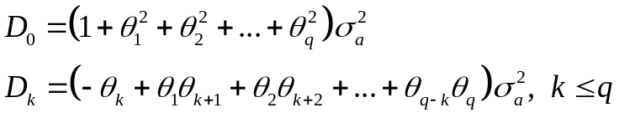 (5.34)
From here autocorrelation function coefficients can be estimated as:
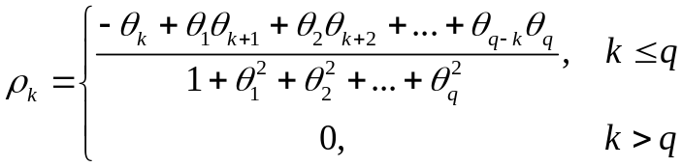 (5.35)
As it is visible from (5.35) autocorrelation function of the MA process breaks on q delay. If estimates of autocorrelation functions are known, then q of the equations can be permitted concerning model parameters MA. There is a problem, that unlike Yule-Walker's equations, in this system the equations are not linear. Therefore for processes of the MA the general expressions for search of coefficients are not estimated.

5.1. Moving-average model of first order
Let the stationary time series оf length N have a model оf MA(1):
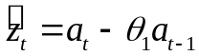, (5.36)
where – the sequence оf uncorrelated stochastic variables with known parameters и .
Then the process autocorrelation coefficient is:
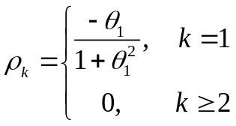 (5.37)
We receive the quadratic equation in form 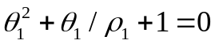. In this equation we have two roots with their product equal 1. On the condition of 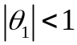, we need to choose only one root with which is below one .

5.2. Moving average model of second order
Let the stationary time series оf length N have a model оf MA(2):
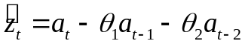, (5.38)
where – the sequence оf uncorrelated stochastic variables with known parameters и .
Then the process autocorrelation coefficients are:
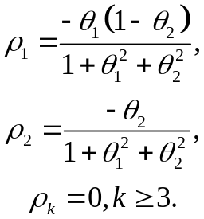 (5.39)
The solutions оf this equations are 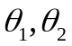. This system is solvable, but hardly described in simple descriptions. Similarly we can construct the MA models of higher order.

Part 6. Complex ARMA and ARIMA models

6.1. Autoregressive – moving-average (ARMA) model
Let's remind that the ARMA(p,q) model is described by expression (5.11) or in short form 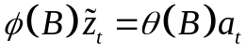. Such model can be interpreted as the linear filter of multiple regression (where the nature of system is explained by its last values), and acts as a remaining balance moving averages from noise elements.
There is Wold's theorem which claims that any stationary TS can be represented in the form of process of the moving-average of infinite degree. At the same time the ARMA models and models MA are mutual on the properties. Moreover, range of process of MA inverse to range of the corresponding process AR of the same order.
As a result, the ARMA (p,q) stationary models can be studied from two points о view:
- As the process AR(p) 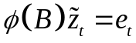, which has a noise 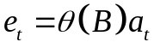 similar to MA(q) process;
- As the process MA(q) 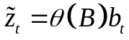, where noise 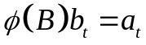 is similar to the AR(p) process.

From here it turns out that, relying on the creation techniques AR and the MA processes described earlier it is possible to build and study, including, and the ARMA models of any order of p and q. A question is which one of these methods is more convenient. Here comes the Wold's theorem: any ARMA process can be represented in the form of the MA process of an infinite order, only with restrictions for structure of coefficients (not to violate a condition of stationarity of an autoregressive part of data).

If to calculate a technique of creation of ARMA model on the basis of set stationary by TS (1,1) orders are similar to the examples which are stated above it is too difficult for calculation, even for basic models. On practice there three overall methods of estimation for ARMA models:

- creation on the basis of Wold's theorem a MA model of an infinite order where this infinity is replaced with some boundary large number;
- use of the least-squares method for linear regression – in the form of a solution of a system of equations;
- use of the conventional methods of maximum likelihood;

Because own calculations necessary for establishment of compliance between TS and its ARMA model, are very difficult, the majority of mathematical and software packages already contain means and functions for creation and assessment of parameters of the built ARMA of models. But any of these means cannot effectively evaluate value of an order (p, q) for these models therefore the researcher has to undertake this task.

6.2. Autoregressive – integrated moving-average (ARIMA) model
As it was already mentioned earlier, the ARIMA models (also known as Box-Jenkins models) оf order (p, d, q) are the ARMA expansion of models for non-stationary TS, at the expense of the assumption that data can be made quasi-stationary taking on differences of some order from initial TS. In a general view the ARMA model noted as
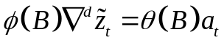. (5.40)
At d=0 the model degenerates in ARMA order model (p, q). On the other hand the ARIMA model (p, d, q) can be treated as ARMA (p+d, q) model, with exactly d unit roots.
Overall, approach of the estimation of ARIMA models is often called by the Box-Jenkins technique, is that at first assessment of stationarity of data by means of statistical criterions is made. By means of the same criteria it is possible to determine number of unit roots d, thereby having defined an order of the difference which is required for reduction of a row to a stationary type at the expense of a difference of the corresponding order.
For such transformed model the condition of stationarity is satisfied and it can be processed already just as the order ARMA model (p, q). That is the analysis technique of the ARIMA models differs from ARMA analysis technique in existence of an additional initial step of search of the satisfying difference degree. On practice it happens that 1 or 2 order of difference is enough, at 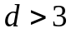 it is possible with high probability to consider that this non-stationary time series by no means of the difference scheme cannot be brought to a stationary type. In this case TS will be better to be analyzed by means of adaptive methods.

Part 7. General technique for initial estimation of ARMA and ARIMA coefficients
As processes of ARIMA, AR and the MA of any order can be reduced to the general of the ARMA models for process of an order (p, q), it would be desirable to have near at hand some technique at least of initial assessment of parameters of the mixed ARMA model.
The general technique looks as follows:

- Generally calculation of initial process evaluations of ARMA (p, q) is based on the first p+q+1 autocovariances 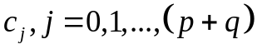.
- Autoregressive parameters 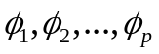 are estimated from found 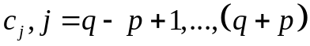.
- Based on estimates of we calculate q+1 autocovariances 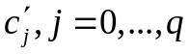 for estimated series 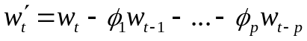.
- At last, autocovariances are used in iterative calculation о initial estimates оf parameters for MA 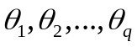 and for residual variance.

Initial estimates of the ARMA parameters (step 2) are made on the basis of a solution of a linear equation system:

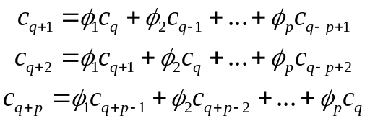 (5.41)

After finding о the ARMA parameters it is possible to transform time series into the form 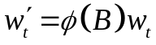 and then study it as MA process. Its new autocovariances are estimated, as (step 3):
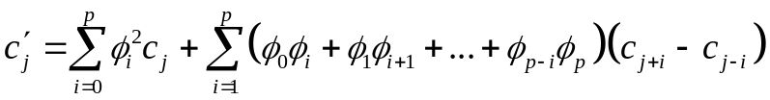 . (5.42)
In the end (step 4) we estimate the variance:
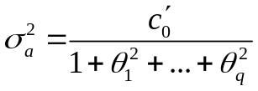 (5.43)
and the parameters
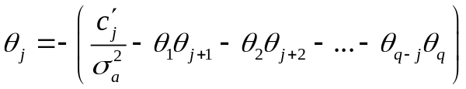 (5.44)
With this the technique of creation of assessment of the ARMA parameters of model can be considered complete.

References

1. Box G., Jenkins G. Time Series Analysis: Forecasting and Control. — 4th ed. Wiley. — 2008. — 784 p.
2. Robert H. Shumway, David Stoffer. Time Series Analysis and Its Applications. — Springer Texts in Statistics, 4th ed. — 2016. — 550 p. ISBN 978-3-319-52451-1.
3. Karter J. Time series analysis with MATLAB. ARIMA/VARMAX/GARCH/GJR Models. Functions and Examples. — 2016. — 422 p. ISBN 978-1-539-54638-2.

